Create your Apple ID on an iPhone, iPad, or iPod Touch

1. Open the App Store, iTunes Store, or iBooks Store on your iOS device.
2. Choose any **FREE** app, song, video, or book.
3. Tap **Get** next to the item, then tap again to get it.

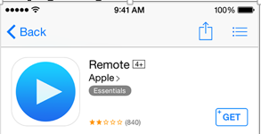

1. When you're asked to sign in with an Apple ID, tap Create New Apple ID.
2. Follow the onscreen instructions. When you're asked for payment information, choose None. [See what to do if None isn't showing or you can't select it.](http://support.apple.com/kb/TS5366)

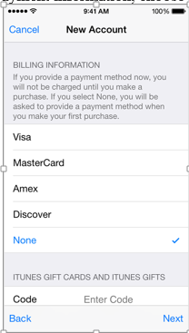

**What to do if None isn't showing or you can't select it.**

If you're [using the store for the first time with an existing Apple ID](http://support.apple.com/kb/HT2589), you must provide a payment method. After you create the account, you can [change your payment information](http://support.apple.com/kb/HT1918) to None.

1. After you enter all of the information required, you'll be asked to verify your Apple ID by email. You must verify your Apple ID before you can begin using it.